Welcome to the Women in High Performance Coaching (WiHPC): Road Map to Action
This self-assessment tool has been developed to support National Sporting Organisations (NSOs), National Sporting Organisations with a Disability (NSODs), State Sporting Organisations (SSOs), clubs, and individuals in evaluating their current environment and practices related to women in high performance (HP) coaching roles. By identifying existing gaps and opportunities, this tool helps you create a tailored roadmap to foster a more inclusive and supportive culture for women in HP coaching. It’s designed to guide your organisation in taking meaningful first steps toward long-term change.
What to Expect:
- 7 key steps with 16 targeted questions to assess your current position.
- A personalised action plan with practical and evidence-based resources to support implementation.
- The ability to reassess over time, helping you track progress and refine your approach.
- This survey will take approximately 15-20 minutes to complete (providing you have workforce data available).
- Data collected by the Australian Sports Commission (ASC) to ensure sector-wide support and alignment with national priorities. This tool is part of a broader commitment to diversity and inclusion in sport. By using it, you're contributing to a stronger, more equitable coaching landscape.
Upon completion of the survey, return to the Road Map to Action to begin your Action Planning.
Your Current Scorecard | Date:
Section 2
Section 3
Section 4
Section 5
Section 6
Section 7
Total Score | /51
Your Percentage | %
Comments

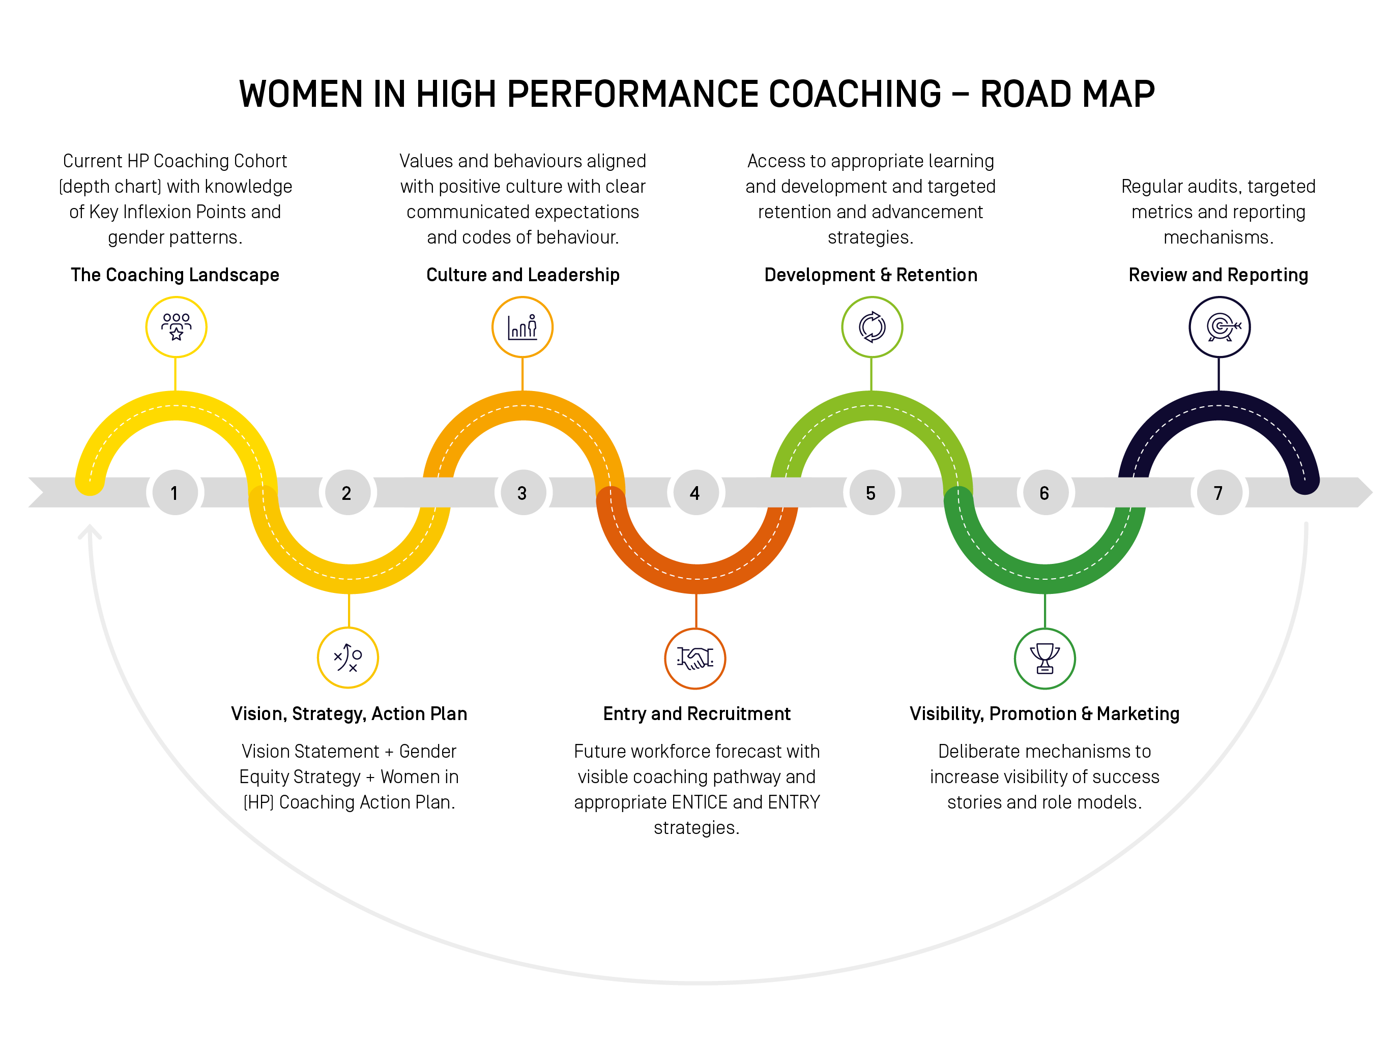

Step 1: The Coaching Landscape
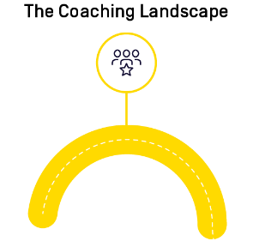 | Aim | Considerations
 | Understand your current HP coaching cohort and their skills and capabilities. Ideally you want to build knowledge of:  - The Coaching Pipeline underneath the HP Coaches  - Identified areas of pipeline narrowing  - Identified inflexion points that impact upon coaches. | Is your coaching population representative of your athlete cohort?  Do you need more coaches, coaches with stronger capabilities or a change in the diversity in your workforce?  If you are not aware of this, what information might you need to inform you and how might you find this
Your Score | NA
Question 1A | Please provide numbers of coaches in each category, to the best of your ability: HIGH PERFORMANCE COACHES  - Men =  - Women =  - Gender Diverse =  - TOTAL = | Definitions are provided below each category.  HIGH PERFORMANCE COACHES  (Coaching athletes at Senior and Junior National Team level, majority are working categorised athletes)
 | TALENT / DEVELOPMENT COACHES  - Men =  - Women =  - Gender Diverse =  - TOTAL = | TALENT / DEVELOPMENT COACHES  (Coaching athletes in the talent / development pathway, may be working with categorised athletes)
 | COMPETITIVE COACHES  - Men =  - Women =  - Gender Diverse =  - TOTAL = | COMPETITIVE COACHES  (Coaching athletes at the Regional and / State level, who may have potential to progress, but primarily coaching pre-pathways level)
 | FOUNDATION / COMMUNITY COACHES  (Coaching recreational athletes, includes all other coaches)  - Men =  - Women =  - Gender Diverse =  - TOTAL = | FOUNDATION / COMMUNITY COACHES  (Coaching recreational athletes, includes all other coaches)

Step 2: Vision, Strategy, Action Plan
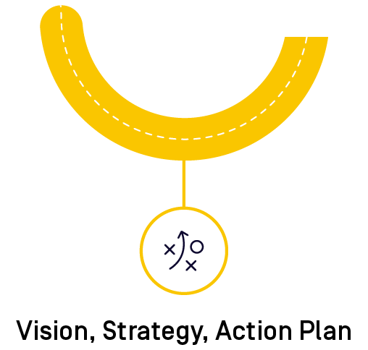 | Aim | Considerations
 | To ensure your organisation has clarity of the following:  - A Vision statement for gender equity in HP Coaching.  - A Strategy to address gender equity in HP Coaching.  - An Action Plan to support women in HP coaching with practical and applicable interventions to impact upon your organisation/sport  Some elements may be embedded into broader organisational strategic plans and vision statements.  If so, do these need to be elevated or clarified? Consider work previously undertaken and the impact of this. | Refer to the examples we have shared in the Road Map: WiHPC Roadmap  Consider who has responsibility for establishing the vision, strategy and action plan.  It is imperative to ensure alignment with board governance and HP leadership.
Your Score | /15
 | For each question, please read each response option and choose the one that is closest to the position of your organisation (Numbers at the end of each response indicate the score).
Question 2 | Does your organisation have a strategy and/or vision statement for supporting Women in High Performance Coaching? This could be a separate document or be part of a more general Women in Sport strategy:  - No, we don't have a documented strategy or vision in place (0)  - No, we don't have a documented strategy for Women in HP coaching but have an element of our organisational vision that refers to gender equity (1)  - Yes, we have a documented strategy, however it doesn't have specific targets or resources attached (2)  - Yes, we have a documented strategy that is fully endorsed, funded, and appropriate resources are in place to meet objectives and key targets. Regular reviews are undertaken to ensure ongoing progress and impact is being measured (3)
Question 3 | Does your organisation deliberately work towards gender equity in the following areas?  Board representation  - No, not at all (0)  - Yes, informally (1)  - Yes, formally, but no targets are set (2)  - Yes, formally, with targets set and progress measured (3)  HP leadership  - No, not at all (0)  - Yes, informally (1)  - Yes, formally, but no targets are set (2)  - Yes, formally, with targets set and progress measured (3)  HP coaching  - No, not at all (0)  - Yes, informally (1)  - Yes, formally, but no targets are set (2)  - Yes, formally, with targets set and progress measured (3) | Definitions:  "Informally" means there are no documented policies or strategies in place but the organisation is aware of its gender balance and knows it needs addressing  "Formally" means the organisation has documented policies or strategies in place in relation to gender equity
Question 4 | Does your organisation have a Women in (HP) Coaching Action Plan?  - No, we don't have an Action Plan in place (0)  - We don't have a documented Action Plan, but we do discuss this regularly as an area requiring support and undertake some activities (1)  - Yes, we have a documented Action Plan, however, don't have specific targets or resources in place (2)  - Yes, we have a documented Action Plan that is fully endorsed, funded, and appropriate resources in place to meet objectives and key targets. Regular reviews are undertaken or planned to ensure ongoing progress and impact is being measured (3) | Definitions:  "Women in (HP) Coaching Plan" - a document that provides information on how the organisation's strategy, vision or targets regarding women in high performance coaching will be achieved.

Step 3: Culture and Leadership
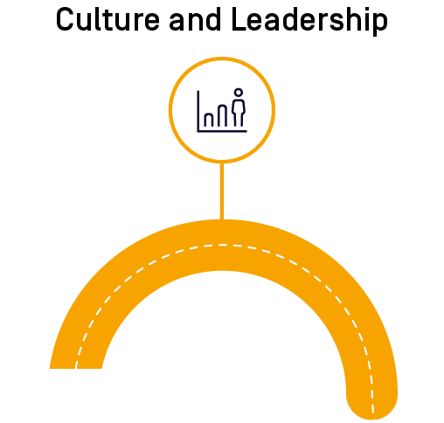 | Aim | Considerations
 | To encourage HP organisations and sports to actively engage with the Win Well Measures and HP 2032+ strategy.  To ensure the organisational values and behaviours aligned with positive culture with clear communicated expectations and codes of behaviour. | The lived experiences of those working within the organisation / sport should be able to articulate and demonstrate the values and behaviours expected.  How clear is the organisation on what the values and behaviours look like?  What areas have been identified within the Win Well Measures to guide direction and action?
Your Score | /6
Question 5 | Does your organisation have a documented set of values that embrace Equity, Diversity and Inclusion and lead a positive culture for Women and Girls?  - No, we have not documented our values and culture in relation to Equity, Diversity and Inclusion (0)  - Our values and culture are discussed as a board and staff, however we have not formally documented those in relation to Equity, Diversity and Inclusion (1)  - Yes, our values are documented and referred to occasionally by board members and staff particularly in reference to particular incidents. We have some signage to display at our facilities (2)  - Yes, our values are documented as part of our Strategic Plan, acknowledged and embraced as part of board and staff inductions, guide decision making, demonstrated through actions, and displayed online and within our facilities (3) | Who leads and reinforces the values and behaviour?  What role do athletes and coaches play in leading and delivering on these behaviours?
Question 6 | Have you completed a culture check/audit to assess women's experience currently within your organisation?  - No, we have never completed a culture check/audit about any aspect of our culture (0)  - We have a culture check but it did not specifically ask questions regarding women's experience in High Performance Coaching (1)  - Yes, we have, and we have used that data to inform decision making (2)  - Yes, we have and we use that data to deliver, monitor and support organisational culture (3)

Step 4: Entry and Recruitment
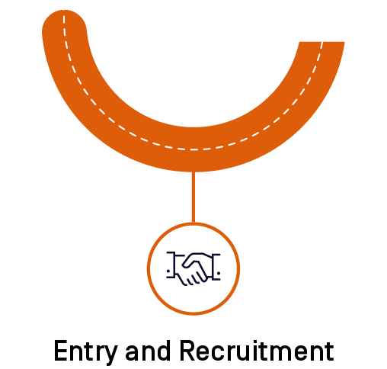 | Aim | Considerations
 | To ensure you have current and future workforce capability to meet the needs of your athletes.  To ensure your organisation has clarity of the following:  - An indication of the required number of coaches, skills and experience and gender within your HP coaching workforce.  - An appropriate strategy to entice women in HP coaching.  - An appropriate strategy to support women upon entering HP coaching. | Consideration of current and future workforce needs will guide your planning needs.  Understanding and application of the HP Coach Capability Framework will be enormously beneficial.  Do you know if there are enough women entering HP coaching? What is the ‘churn’ rate and why?
Your Score | /9
Question 7 | Does your organisation map and forecast the number of coaches required to achieve set targets and goals with particular reference to gender, skills and experience?  - No, we have not mapped our coaching needs and have limited information available (0)  - Not formally, however we have identified a lack of women HP coaches in our current system (1)  - Yes, we have mapped against our current programs and identified a need to recruit, develop and retain coaches in order to meet targets (2)  - Yes, we have a future forecast and targets set for the number of women in HP coaching required to achieve our strategic and performance goals for at least 4 years. This is supported by a recruitment and development plan to meet objectives (3) | It is important to consider how you currently entice and recruit women into HP coaching.  Do you have open transparent recruitment practices (for both paid and honorarium roles)?
Question 8 | Are there enough women entering High Performance coaching in your organisation?  - No, we do not have enough women entering our HP coaching system (0)  - We think so, but don't have enough evidence or data to make a clear determination (1)  - Yes, but we would like to still improve the overall percentage of women entering our sport as HP coaches (2)  - Yes, we have met the targets we set ourselves for women entering our sport as HP coaches and we continue to monitor and review (3)
Question 9 | Does your organisation currently have a targeted and supported approach to recruitment of Women in High Performance Coaching?  - No, and we have never tried a targeted approach (0)  - We currently have a targeted approach, but it isn't working (or have had one in the past and it hasn't worked) (1)  - We currently have a targeted approach, but we don't know if it is working or not as it isn't supported by policies or monitored (2)  - Yes, we have a specific recruitment approach including systems, tools and language supported by organisation policies to attract and recruit WiHPC and it is successful (3)

Step 5: Development and Retention
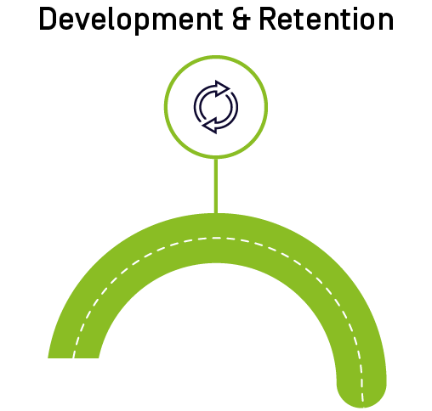 | Aim | Considerations
 | To ensure your development and retention strategies meet the needs of your coaching workforce.  To ensure your organisation provides:  - Adequate access to appropriate learning and development opportunities,  - An optimal learning environment that is openly inclusive and welcoming,  - A visible coaching ‘pathway’ for progression,  - A diverse coach development workforce,  - Targeted retention and advancement strategies. | What insights might you need to gain before being able to answer these questions with accuracy?  Mapping the ‘leaks’ to the pipeline could provide an indication of potential target areas to better understand and intervene.  Consider the informal and formal learning programs you deliver to support HP coaches.  Consider the learning and development landscape in your sport and how accreditation aligns or connects with HP coach development.  Do your coaches advance to leadership roles? Why / Why not?
Your Score | /9
Question 10 | Are women coaches in your sport accessing and receiving adequate and appropriate development opportunities?  - No, we don't think they are (0)  - We believe they are, but we have not done an audit to confirm or have evidence to say that they are (1)  - Yes, we have done an audit and heard directly from the women that they are (2)  - Yes, we have done an audit and have applied deliberate strategies to support development (3) | The gap between the workforce / education team within the organisation and the HP management and development team can be a determining factor in impacting in this space.
Question 11 | Does your organisation have a targeted development program or other strategies that deliberately focus on the retention of women coaches?  - No, and we have no idea how many women are leaving the profession and why (0)  - No, we know that some women stay in coaching but don't have any data or evidence as to why (1)  - Yes, we have a development program in place to encourage women to stay in their positions, however this is not supported through funding or data (2)  - Yes, we have a documented and funded development and retention program that supports women in coaching as a career. We have a robust set of policies and systems to track retention and development (3)
Question 12 | Are women coaches advancing to leadership positions? (i.e. advancing in leadership responsibilities)  - No, they are not (0)  - Some are, but numbers are low and the progression clearly narrows (1)  - Yes, we think there is a clear pathway for women to advance to leadership positions. However, we don't have targets or monitoring in place (2)  - Yes, there is a clear professional development pathway for women to advance to leadership positions, we have clear targets, and this is monitored (3)
Step 6: Visibility, Promotion & Marketing
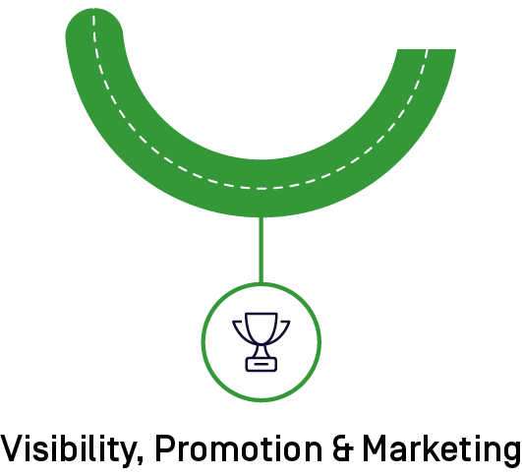 | Aim | Considerations
 | To deliver deliberate mechanisms to increase visibility of success stories and role models.  To ensure your organisation establishes and maintains dialogue with women coaches directly regarding their priorities, preferences and needs in relation to HP coaching and the broader community. | A simple desktop audit of your social media stories, images and website can spotlight some areas to focus on. In many cases there are minimal photos of coaches in action, and in most cases there are very few images of women coaches.  Consider what myths might need challenging within your HP coaching landscape.  Consider the language the organisation and HP management utilise when announcing teams, success and promoting leadership and recruitment.
Your Score | /9
Question 13 | Have you established and/or maintained dialogue with women about their priorities, preferences and needs in relation to HP coaching?  - No, we have not consulted with women coaches on specific needs or programs (0)  - We have asked some informal questions however do not have a formal or regular process in place (1)  - Yes, we have occasionally consulted with the HP coaching community and run a regular survey to ask for any specific feedback and ideas (2)  - Yes, we have an active network group that helps us understand the specific needs, challenges and opportunities to grow and enhance HP coaching with feedback actively reviewed by staff and program leads (3) | Talk to the coaches and those they work with!
Question 14 | Does your organisation use appropriate language and images to promote a welcoming and inclusive culture within your organisation?  - We only provide general information. We don't promote with any targeted messages (0)  - Sometimes, on specific promotions and campaigns (1)  - Yes, we use a range of images and language to promote and encourage increased participation by women and girls (2)  - Yes, our promotional material, messaging and imagery is co-designed with the key stakeholders to align messages and encourage increased engagement of a diverse range of women and girls (3)
Question 15 | Does your organisation celebrate women in High Performance including, coaching, management, performance support etc.?  - We don't consider celebrating isolated achievements (0)  - We acknowledge their contributions, but don't celebrate (1)  - We don't celebrate specific achievements but would like to get better at this (2)  - Yes, we actively support and promote women and girls in everything we do, particularly emphasising the achievements in HP coaching (3)

Step 7: Review and Reporting
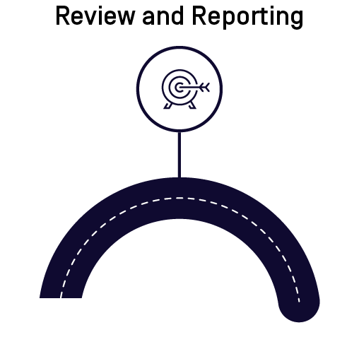 | Aim | Considerations
 | Regular audits, targeted metrics and reporting mechanisms. | It is important to have an identified individual who is responsible for this work and held accountable. It is also important to have a communication and reporting plan back to your community.  Consider appropriate and relevant timelines for revisiting this checklist and action plan.  Ensure your targets and actions are achievable with visibility of impact of your interventions.
Your Score | /3
Question 16 | Have you implemented effective strategies to ensure regular reviews and data collection on Women in High Performance Coaching?  - No, we have not (0)  - We have commenced some strategies, but have minimal or no data on progress or reporting (1)  - We have some basic data and commenced some strategies but lack regular reviews and reporting procedures (2)  - Yes, we have regular audits, feedback mechanisms, and data collection that are reviewed and inform our decision making on a regular basis (3)

